Worl War II War in the Air


Items highlighted in yellow are tasks for you to complete
Items in Blue italics are help tips

Open the Power point War in the air WW2

And open the logos file. Air Logos.zip

1. Insert a logo corresponding to the correct aircraft on each page as a button to hyperlink to the next slide. Note some images are screen shots and most will need to be re-sized.

2. Complete the slide show and revove all automatic transitions so that ONLY your button links move slides forward

Note some have already been inserted for you.

Save your work..
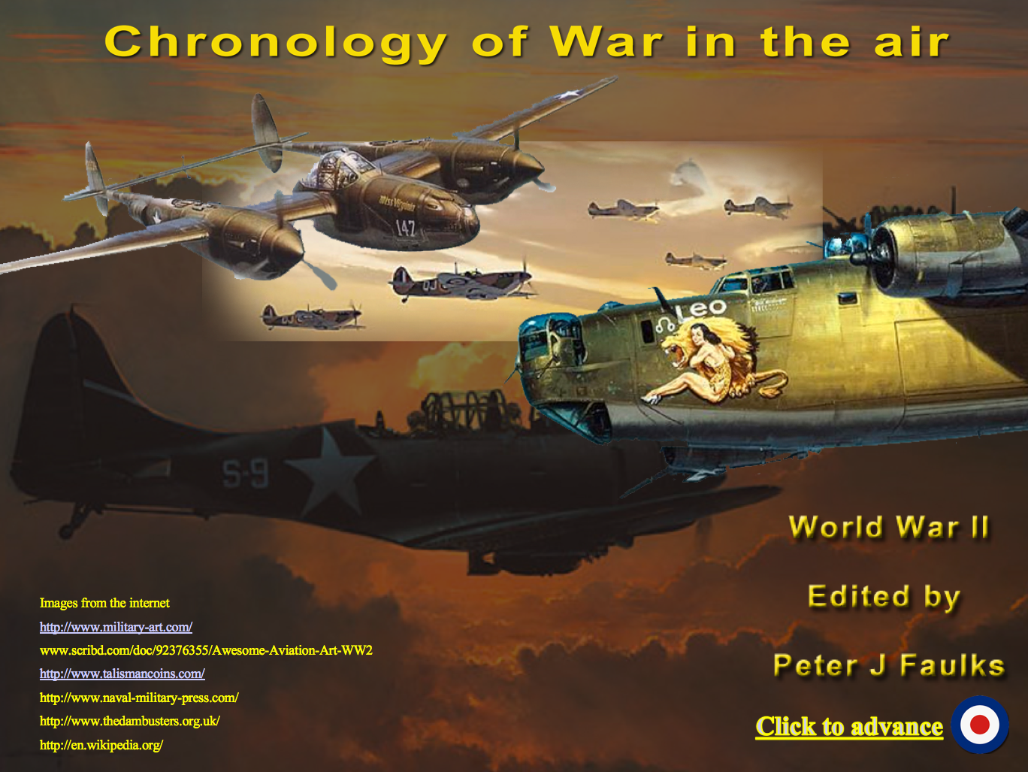

Sample images
